EduNexus
  - Intelligent Insight and Automation Platform for Academic Institutions
Version: 1.0

Prepared By: 26-FYP-217 — Salahudin, Hussain, Qamber Ali
Supervised By: Dr Haseeb Ahmad
Date: November 2025
Contents
1. Introduction 4
1.1 Purpose 4
1.2 Scope 4
1.3 Definitions, Acronyms, and Abbreviations 4
1.4 References 5
2. Overall Description 5
2.1 Product Perspective 5
2.2 Product Functions 5
2.3 User Characteristics 6
2.4 Constraints 6
2.5 Assumptions and Dependencies 6
3. Specific Requirements 6
3.1 Functional Requirements 6
3.1.1 Authentication & Role Management 6
3.1.2 Attendance Management 6
3.1.3 Report Cards 7
3.1.4 Timetable Management 7
3.1.5 Complaints & Feedback 7
3.1.6 Homework Management 7
3.1.7 Fee Management 7
3.1.8 AI Query & Insight System 7
3.1.9 Notifications & Communication 7
3.2 Non-Functional Requirements 8
3.2.1 Performance 8
3.2.2 Security 8
3.2.3 Usability 8
3.2.4 Reliability 8
3.2.5 Maintainability 8
4. System Design Overview 8
5. Appendix 9
6. System Models and Diagrams 9
6.1 System Architecture Diagram 9
6.2 Use Case Diagram 10
6.3 Data Flow Diagram (DFD) 11
6.4 ER Diagram (Entity-Relationship Diagram) 12
7. Other Requirements 13
7.1 Future Enhancements 13
7.2 Limitations 13
7.3 Risks 13

1. Introduction

1.1 Purpose
The purpose of this document is to define the functional, non-functional, and system requirements for the EduNexus platform — an intelligent, AI-assisted academic automation and insight system. It will guide developers, testers, and stakeholders in understanding the complete functionality and behavior of the system.

1.2 Scope
EduNexus is designed to simplify academic data management and enhance decision-making through automation, analytics, and natural language interaction.
It integrates daily academic operations — attendance, performance tracking, report cards, and communication — into one intelligent dashboard. The system will be web-based, developed using React.js, Node.js, and integrated with API-based Large Language Models (LLMs) for analytical querying and reporting.
Key features include:
- Automated attendance, report generation, and notifications.
- Natural language querying for academic insights.
- Role-based portals (Admin, Teacher, Parent).
- Exportable reports in PDF and Excel formats.
- Centralized dashboard for monitoring institutional performance.

1.3 Definitions, Acronyms, and Abbreviations
Term | Definition
LLM | Large Language Model used for AI-driven querying and summarization
RAG | Retrieval Augmented Generation – method for precise data-driven responses
API | Application Programming Interface

1.4 References
- IEEE Std 830-1998, IEEE Recommended Practice for Software Requirements Specification
- React.js Documentation (Meta, 2025)
- Node.js Documentation (Node Foundation, 2025)
- MongoDB & PostgreSQL official documentation
- jsPDF, ExcelJS Libraries
- LLM API documentation (OpenAI / Google / Anthropic)

2. Overall Description

2.1 Product Perspective
EduNexus is a standalone web-based application that integrates existing academic workflows into an intelligent automation ecosystem. It will serve as the centralized digital platform for institutions to manage their daily academic data and generate real-time insights.

2.2 Product Functions
- Attendance Automation: Teachers mark daily attendance; data auto-summarized for analytics.
- Report Generation: Automated report cards based on teacher inputs.
- Academic Dashboard: Real-time analytics for admin to monitor institutional performance.
- Communication System: Secure two-way messaging between admin, teachers, and parents.
- Complaint & Feedback: System to submit and track complaints or feedback.
- AI Querying Agent: LLM-based assistant to interpret natural language questions about institutional data.

2.3 User Characteristics
Actor | Characteristics | Privileges
Admin | Tech-skilled staff managing the full system | • Full system access  • Manage users & roles  • Configure system settings  • View all reports (Academics, Finance, HR)  • Monitor system activity
Principal | Senior leadership with strong digital use | • View school-wide reports  • Approve requests & announcements  • Monitor teacher performance  • Access academic insights  • Send global notices
Finance | Accounting-focused staff with moderate tech skills | • Manage student fees  • Generate fee slips  • Track payments & dues  • Handle refunds/expenses  • Generate financial reports
Reception | Front-desk staff with basic digital skills | • Manage admissions entries  • Handle inquiries & appointments  • Maintain visitor logs  • Update student personal data
HR | Staff management professionals with system knowledge | • Manage staff profiles  • Process payroll & salaries  • Handle leave requests  • Track staff attendance  • Generate HR reports
Teachers | Classroom managers with basic tech literacy | • Mark student attendance  • Upload grades & homework  • Share learning materials  • Communicate with parents  • View student progress
Students | Learners with basic digital familiarity | • View timetable & homework  • Submit assignments  • View grades & attendance  • Receive announcements
Parents | Moderate tech users monitoring child progress | • View child’s grades & attendance  • Check fee status  • Communicate with teachers  • Submit complaints/feedback  • Receive school updates

2.4 Constraints
- Internet connection required for all functionalities.
- AI query accuracy depends on dataset quality.
- Real-time data updates require backend synchronization and stable API connection.

2.5 Assumptions and Dependencies
- Institution provides digital academic records for initial data migration.
- APIs for LLM services and report exports (jsPDF, ExcelJS) remain available.
- Users access through modern browsers (Chrome, Edge, Firefox).

3. Specific Requirements

3.1 Functional Requirements
FR-1: The system shall provide secure JWT-based authentication and enforce encrypted password validation, ensuring that dashboards and system access are loaded according to each user’s assigned role and permissions.
FR-2: The system shall allow the Admin to create, update, and delete user roles and assign corresponding permissions for all roles, including Admin, Principal, Finance, HR, Reception, Teachers, Students, and Parents.
FR-3: The system shall allow Teachers to record and modify daily attendance, while Admin, Principal, HR, Parents, Students, and Reception shall access attendance summaries or detailed views according to their access level.
FR-4: The system shall allow Teachers to input marks, grades, and comments, auto-generate report cards, enable Principals to approve final batches, and allow Students and Parents to view or download published report cards.
FR-5: The system shall allow the Admin to upload or edit class timetables, and allow Teachers, Students, Parents, Principal, and Reception to access updated timetables with role-appropriate visibility.
FR-6: The system shall allow Teachers, Parents, and Students to submit complaints or feedback, allow Admin to track, assign, and resolve complaints, and provide real-time status updates to the original submitter.
FR-7: The system shall allow Teachers to post homework, allow Students to submit homework digitally, allow Parents to view homework, and allow Admin and Principal to audit homework posting and workload patterns.
FR-8: The system shall allow Admin and Finance to manage fee structures, payment details, concessions, receipts, and financial reports, while allowing Parents, Students, and Reception to view fee status based on permissions.
FR-9: The system shall provide an AI-powered query engine capable of interpreting natural-language questions and returning insights, summaries, charts, or downloadable reports according to each user’s role permissions.
FR-10: The system shall support secure internal messaging and push notifications for events including attendance changes, grade updates, announcements, fee reminders, holidays, staff notices, and system alerts.

3.2 Non-Functional Requirements
NFR-1: The system shall support a minimum of 100 concurrent users and maintain response times under 90 seconds for dashboards, reports, queries, and AI-generated insights, with key metrics refreshing at least every 5 minutes.
NFR-2: The system shall secure all communications using HTTPS, enforce JWT-based authentication, and strictly apply role-based access control for all user categories.
NFR-3: The system shall protect all sensitive information—including grades, fee data, and payroll—through encryption at rest and in transit, and require MFA for Admin, Principal, and Finance roles.
NFR-4: The system shall provide a responsive, WCAG 2.1–compliant interface that functions across desktop, tablet, and mobile devices to ensure accessibility and usability for all users.
NFR-5: The system shall offer user assistance through tooltips, guided help, contextual prompts, and customizable dashboards tailored to each role’s frequently used functions.
NFR-6: The system shall maintain at least 90% uptime under normal load and ensure operational reliability for all core institutional processes.
NFR-7: The system shall perform automatic daily backups with full restoration capability for all critical data to ensure data integrity and recoverability.
NFR-8: The system shall maintain a modular, well-documented codebase, provide comprehensive API documentation, and include logging, monitoring, and error tracking tools to support efficient maintenance and troubleshooting.

4. System Design Overview
- Frontend: React.js with TailwindCSS for responsive UI.
- Backend: Node.js (Express) handling business logic and API communication.
- Database: MongoDB or PostgreSQL for storing institutional data.
- LLM Integration: API-based natural language model for data querying.
- Automation Workflows: Orchestrated via internal pipelines for task triggers.
- Reporting Tools: jsPDF and ExcelJS for exportable analytics.

5. Appendix
- Future Integrations: Predictive analytics, mobile app, voice-based assistant.
- Project Methodology: Iterative Waterfall (phase-based with revisions).
- Development Tools: GitHub, Docker, Postman, Vercel.

6. System Models and Diagrams

6.1 System Architecture Diagram
Purpose:
Shows the overall structure of EduNexus — how users, components, and the AI system interact.
Should Include:
- Users/Portals: Admin, Teacher, Parent
- Frontend: React.js Client
- Backend: Node.js Server (APIs)
- Database: MongoDB/PostgreSQL
- LLM Service: API-based AI Query Layer (RAG-based)
- Reporting Tools: jsPDF / ExcelJS
- Automation Layer: Triggers for notifications, backups, and reminders
Diagram:
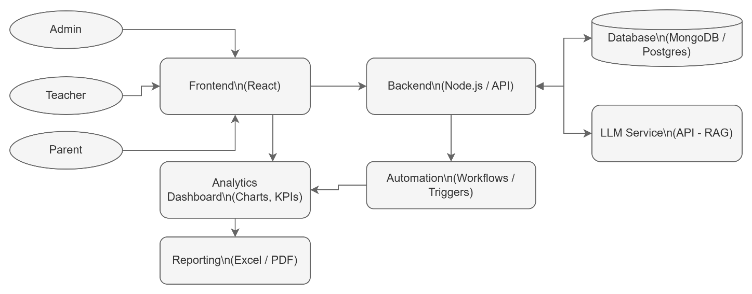

6.2 Use Case Diagram
Purpose:
Represents system interactions between actors (users) and functional modules.
Actors:

- Admin
- Teacher
- Parent

Use Cases (Functions):

- Manage Attendance
- Generate Report Cards
- View Performance
- Submit Complaints
- Post Homework
- View Notifications
- Query AI Insights

Diagram:
To be added.

6.3 Data Flow Diagram (DFD)
Purpose:
Shows how data moves through the system.
Level 0 (Context Diagram):
High-level flow between system and users.
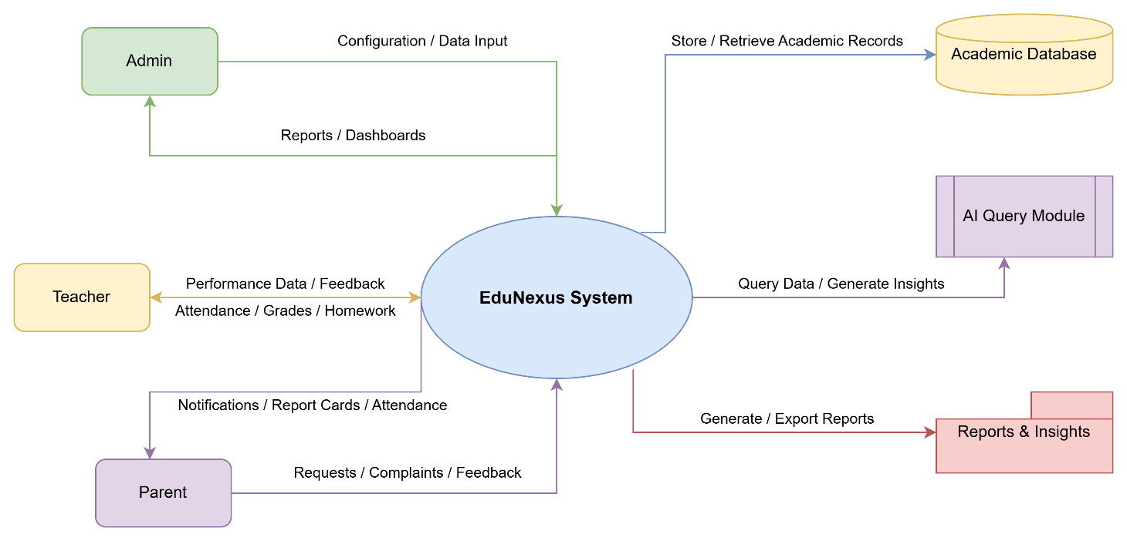
Level 1:
Detailed sub-processes (Attendance, Reports, AI Query, etc.)
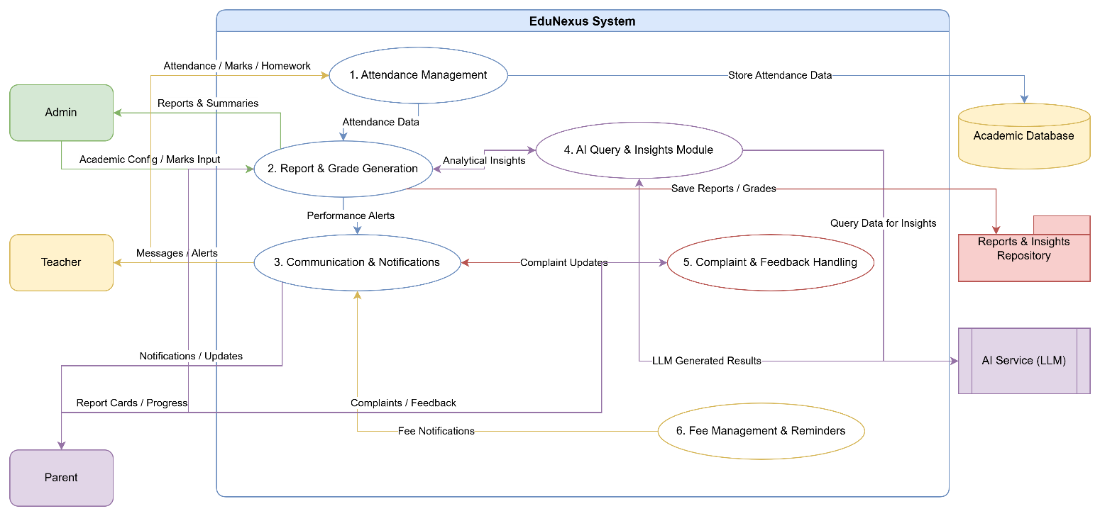

6.4 ER Diagram (Entity-Relationship Diagram)
Purpose:
Shows the database structure — how data entities are connected.
Main Entities:
- User (UserID, Name, Role, Email, Password)
- Student (StudentID, Name, Class, Section, ParentID)
- Attendance (AttendanceID, Date, Status, StudentID, TeacherID)
- ReportCard (ReportID, Marks, Remarks, StudentID, SubjectID)
- Subject (SubjectID, Name, TeacherID)
- Fee (FeeID, Amount, Status, StudentID)
- Complaint (ComplaintID, Type, Description, Status, UserID)
- Message (MessageID, SenderID, ReceiverID, Content, Timestamp)
Diagram:
To be added.

7. Other Requirements

7.1 Future Enhancements
- Integration of predictive analytics for student performance forecasting.
- Voice-based conversational assistant for queries.
- Mobile application for real-time notifications.
- Advanced BI (Business Intelligence) module for institutional trends.

7.2 Limitations
- Dependent on internet connectivity and cloud APIs.
- LLM responses may occasionally lack context-specific precision.
- Limited offline functionality for certain modules (e.g., reporting).

7.3 Risks
Risk | Impact | Mitigation
LLM API downtime | Disrupts AI-based queries | Local fallback for limited query handling
Data breaches | High | JWT + Encryption + Access Control
Miscommunication in AI responses | Medium | Implement validation layer for AI outputs
Delayed data sync | Low | Scheduled auto-sync routines

